

*January 2013*

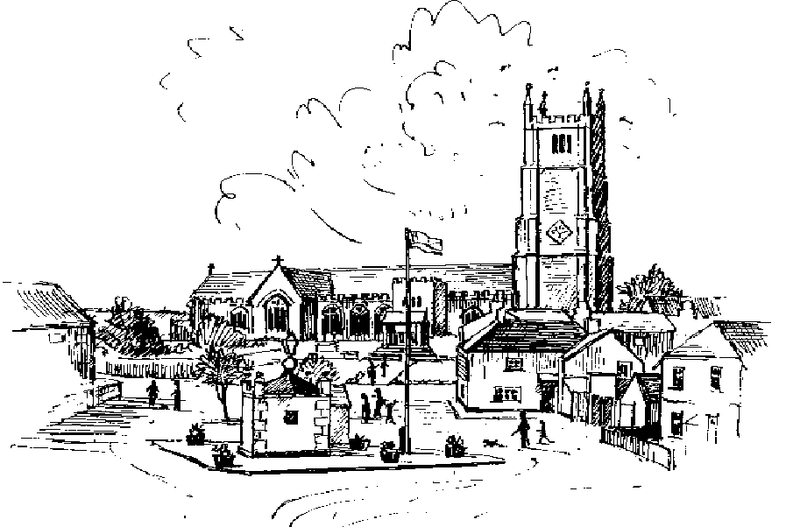

What’s on

|  |  |  |
| --- | --- | --- |
| Tuesday 8th January | 1st day of term- Ugborough Primary School | Page 2 |
| Wednesday 9th January | Ugborough Parish Council meets at Ugborough Village Hall at 7.30p.m. | Page 8 |
| Thursday 10th January | Public meeting to discuss Neighbourhood Plan at Ugborough Village Hall from 7.30p.m. to 9.30 p.m. | Pages 8 and 9 |
| Wednesday 23rd January | Ivybridge and District Inter-parish Quiz at Ugborough Village Hall at 8 p.m. | Page 2 |
| Monday 28th January | Ivybridge U3A meeting at Ivybridge Methodist Church  at 2 p.m. | Page 7 |
| Wednesday 30th January | Ugborough Local History Group meets at Ugborough Village Hall at 8 p.m. | Page 4 |
| Saturday 2nd February | Ugborough Safari Supper | Page 3 |

Details of services at Bittaford Methodist Church are on page 11.

Details of services at St. Peter’s Church, Ugborough are on page 11.

UGBOROUGH POST OFFICE AT ST. PETER’S CHURCH

Don’t forget that the Post Office opening hours are-:

Tuesdays from 1.30 p.m. to 3.30 p.m.

Thursdays from 10 a.m. to 12 noon. (Coffee and cake available at this time!)

Garden Club *Anne Holway*



Party time! Our New Year Party for members is on Thursday 17th January.

**Coffee Drop-In Centre**

**10am-Noon every Thursday morning in Ugborough Church**

**Post office also available 10am–12 noon**

Why not meet up with friends and neighbours over coffee, tea, cake & biscuits?

Everyone welcome.

Help needed. The Thursday Coffee morning is proving to be very popular and we are very grateful to those who regularly give up their time to make it possible.

However, we now need more volunteers for the rota. If you can’t make a regular commitment, maybe you could help from time to time on a relief basis. Please come along and talk to us about it.

Ceremonial flying of the Flag.



The flag will be flown on the following occasion-

Sunday January 20th- Birthday of the Countess of Wessex.

**2013 Ivybridge and District Inter Parish Quiz**

We entertain Yealmpton in the first round of this year’s quiz.  Please come and support our team in Ugborough Village Hall on Wednesday 23rd January at 8 pm.

The Beacon Federation  *Executive Headteacher - Mrs. Jane Byrne*

Ugborough Primary School.

Happy New Year! We look forward to seeing you all back at school on **Tuesday 8th January 2013.** We are very pleased to confirm that Mr Phillips will return to school in January. Initially, he will work on a part time basis, with Mr Williams, before resuming full time duties.

**Ugborough on Safari!**



Reminder this winter’s Safari Supper is being held on

**Saturday February 2nd**

**Closing date for applications is however**

**January 21st**

**Application forms from John Pursey 01752 896278**

**2 The Old Chapel, Lutterburn Street**

**or**

[ugboroughsafari@gmail.com](mailto:ugboroughsafari@gmail.com)

Ugborough and Bittaford Pre- School. *Naomi Williams*

Happy New Year to all and trust you had an enjoyable Christmas.

This year at pre-school we will continue to observe, assess and plan everything we do and provide, in line with the recently revised Early Years Foundation stage  framework, to ensure all children in our care have the support they deserve to fulfil their potential.  All 2 year olds now have an EYFS progress check, carried out by their key person, to review the child’s development in the three prime areas, this is then shared with the parents.  Staff frequently attend courses, meetings and conferences to ensure they have clear, up-to-date knowledge and skills in all areas of children’s development.  Our exciting Forest Schools program will continue to provide a variety of outdoor experiences and activities on Monday afternoons.  Last term children made Forest pets, mud potions, dens between the trees that became pirate ships and observed the use of the Storm Kettle to produce the water for our delicious hot chocolate.

Our rural pre-school, which was officially judged by OFSTED as “Outstanding” in March 2011, welcomes children from all over the area from 2 years old to school age and we offer 15hrs of funded childcare for 3 and 4 year olds.  Offering two free taster sessions which enable you and your child the time to settle in to a new environment and meet the highly qualified and experienced staff members who will provide a fun, caring and happy experience for each individual.  Our opening hours are Monday, Wednesday and Thursday 9am to 3pm and Tuesday and Friday 9am to 12.45pm, term time only, for further information please contact either Tania or Naomi on 07763 215455.  Likewise, the Toddler Group meets on Monday between 10am and 11.30am phone Sara on 07739 826422 for Toddler Group enquiries.

Ugborough Parish Walking Group- *Merryl Docker*



No walk this first Sunday of the month- it’s official lie in day!

Ugborough Local History Group- *Merryl Docker*

Thank you to all for the wonderful Christmas party evening at Flete House.

What a happy occasion! The next meeting will take place on Wednesday 30th January at 8p.m. at Ugborough Village Hall. By way of a change it will be a film night, ‘The Evacuation of Slapton’ with archive footage and interviews.

Rainfall at West Cannamore, Ugborough, 510 ft. above sea level

Thanks to Len Wakeham for this valuable record.

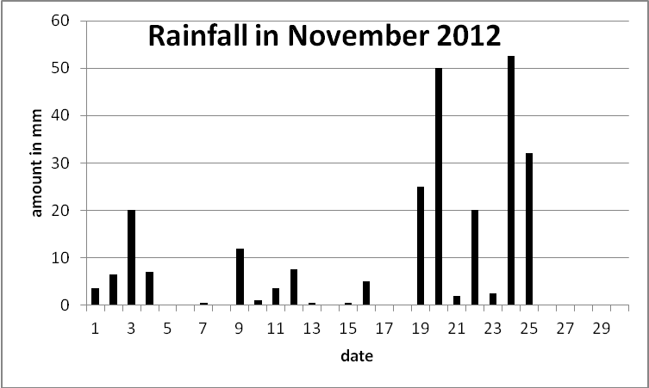

Total for November 251.5mm=9.90 ins.

A huge thank you to Philomena, Judith and members of UGBOROUGH YOUTH GROUP and everyone else who joined the team, for the absolutely brilliant Seniors’ Christmas lunch.

It was such an enjoyable event- excellent food, and friendship!

Thanks also to Andrew for the music. The goody bags were very welcome too!

Thanks also to George Long for the pork- it was delicious!

Book Lovers  *Anne Nonymous*



The secret life of France by Lucy Wadham.

'and now for something completely different......'

moving away from the novel this month, I found this on the library shelf and thought it looked interesting. I have, in the past enjoyed the Peter Mayle books about his life in France and so was delighted to find another author possibly writing in the same vein.

The secret life of France was published in July 2009, and was, I found, very different from Peter Mayle, in that it covered many areas of French life, and although humorous in part it was certainly more serious, than I had imagined.

Lucy tells us of her life in France – married to a Frenchman, her marriage, her children, but mainly her observations, on the differences between our Anglo-Saxon Culture and the French way of looking at the world. Her observations are wide ranging – from sexual manners, the importance of appearance, French history, the French school system, healthcare, the social system and politics (of which there are many!)

I found it a fascinating insight into France and the French and what they really do think of us in the United Kingdom.

Well worth a read, especially if you think of yourself as a 'Francophile'.

Beryl’s Bookworms -*Sue Johns*



It was all about the Christmas Party this month! A sumptuous bring and share feast at the new home of Sue Webster saw all thirteen members enjoy excellent food and company. Six of us had written a Ghost Story – this year’s entertainment - which we read aloud with dimmed lights to add to the atmosphere.

As ever the contrasting styles and interpretation of a given topic was entertaining and interesting. Two of the stories had clever twists, one was so melodramatic it was comical, and three were based on personal experiences – which **was** spooky!

The most memorable story was narrated by someone who had actually lived in a haunted house, and her experience was spine chilling, unbelievable and provoked much discussion on the paranormal.

We all took our leave looking over our shoulders as we found our way to our cars!

Our book for January is ‘Baking Cakes in Kigali’, by Gaile Parkin.



Your Stars Tonight. I tweak back the lace curtains to peer out at the night – no change to the humidity is evident. I consider the advantages of setting up my telescope at the bottom of the Mariana Trench - at least I would only have 7 miles of warm Pacific water between me and the stars. But astronomers are endlessly optimistic and I brighten again at the prospect of two spectacular comets in 2013. In April Comet C/2011 L4 Pan-STARRS should be visible to the naked eye while Comet C/2012 S1 ISON is predicted to be a stunning, once in a life time, sight next November.

Will they live up to their promise? Who knows? The brightness of comets is notoriously difficult to predict – remember the Comet Kohoutek fiasco in 1973?

Recent space probes have shown comets are deep frozen lumps of space debris which, as they get closer to the sun, begin to heat up and squirt out gas, dust and water vapour which then glows in the solar radiation, eventually becoming an extended tail which can stretch for millions of miles. But for most of their lives in they are part of the Oort Cloud where vast numbers orbit in the icy wastes of space beyond Pluto. Occasionally one of these gets nudged out of its orbit and accelerates towards the sun - probably accompanied by a Pink Floyd sound track - and as it gets closer to the sun’s warmth it has its brief moment of glory.

Currently both of these new comets are faint hazy patches but there are high hopes for them because both are calculated to pass round the sun less than a million miles from the sun’s surface and at the best angle for us to see the tail sideways on. But the maths involved is rather challenging – so it may not happen!

The last comet which was easily visible to the naked eye was Hale Bopp back in 1997. I can remember lying in the bracken on Ugborough Beacon one night marvelling at the celestial feather in the velvety dark above - until the spell was broken when a sheep tic decided to join the party. And in 2011 I followed the faint comet 2011 P Garradd as it inched its way across the night sky over several months – it was never more than a faint fuzzy patch - just visible in binoculars if you knew where to look – but it did have an ethereal mystery in its lonely journey around the sun and then back home to the Oort Cloud.

Through-out history comets have been jolly good portents of doom and disaster – Halley’s Comet in 1066 marked the down fall of Anglo-Saxon England (or to be more precise and Anglo-Saxon-Danish-Viking-Romano-British-Celtic England). And so it is today.

The steamed dietor emits a piteous howl as she hunches over her laptop. “It’s gone viral” she groans, “me at the Seniors’ Christmas lunch leading a rousing rendition of My Generation.”

Indeed the curse of Comet C/2012 is upon us.

Ivybridge U3A *- Doreen Flood*

Ivybridge U3A is looking forward to the New Year and we have lined up a varied and interesting list of speakers for our monthly meetings.

The list of groups continues to grow and covers a wide variety of subjects.

For further information go to our website (ivybridge-U3A.org.uk) or contact me on

01548 830237. The general meeting of Ivybridge U3A for January 2013 will be on Monday January 28th at 2.00pm in the Methodist Church, Fore Street, Ivybridge.

The speaker will be Alan Puddington ‘The Jubilee Sailing Trust'.

**Holbeton Players:** The winter production by The Holbeton Players will be

*Oh What a Lovely War*, Joan Littlewood’s West End and film hit. It will take place at Holbeton Village Hall, 6th, 7th, 8th & 9th February 2013.

Tickets, £10, from Helen Waters 01752 830326.

Ugborough Parish Council  *Clerk: Sarah Woodman* Tel: 01626 824568

email: ugboroughpc@yahoo.co.uk Website: [www.ugboroughparishcouncil.gov.uk](http://www.ugboroughparishcouncil.gov.uk)

The December Parish Council Meeting started with an interesting presentation from planning consultant Ed Persse on the possibility of affordable housing in Bittaford. No sites were identified and past experience has shown Dartmoor National Park Authority resistant to new housing developments in Bittaford or Wrangaton, but Councillors will mull over the proposals at their January meeting.

The Police Report identified 8 crimes over the last month, including theft from a garden shed, a back garden and stables. Advice was given on making sure your car was ready for winter – check the tyres, and allow adequate space from the car in front, as stopping distances are greater on wet and icy roads.

A new way to report fraud has been introduced. Contact Action Fraud on

0300 123 2040 or through the website, www.actionfraud.police.uk. There are circumstances in which the police should still be called direct – if the victim is in immediate danger, or there is a chance that the suspect could be caught at that time, or if there is a known local suspect.

The next Police Surgery/Drop in at the Church will be held on Thursday 17 January 10.30-11.30am, when your Neighbourhood Officers Shaun Barker and Jacqui Hopper will be there to discuss crime prevention or any issues you may have.

A new Parish Councillor has been appointed. Two applicants came forward, both with excellent credentials, and it was very hard to choose – in fact, it was suggested that we should create an additional Councillor position in order to keep both applicants (not allowed!). After lengthy deliberations, David Smallridge was appointed as Parish Councillor – he lives in Ludbrook, has a long association with the parish, and successfully runs a local business.

Planning Applications No objections were raised to the proposed garage, workshop and log store at Eden, Glazebrook, nor to the single storey garage/car port/store for new dwelling at Virginia Lodge, Park Cottages, Ugborough – although further details were requested on the construction and height of the proposed wall.

A planning application for stables barn, riding manege, storage container, yard and access at Field SX6546 5605, Davids Lane, Filham received support, subject to additional screening of indigenous planting to the north of the proposed development.

The Neighbourhood Development Plan is moving on to its consultation stage, and I would urge you to complete the questionnaire enclosed with this Newsletter. Parish Councillors will be coming round to collect your completed questionnaires on the weekend of the 19th/20th January, and as they have to call on a lot of households, it would be helpful if your completed questionnaire was ready for collection. A public meeting in Ugborough Village Hall on the 10th January from 7.30-9.30pm is being held to answer any questions you may have – take this opportunity to get involved in the future of your community!

You can also get involved by visiting our new Ugborough Neighbourhood Development Plan Face book page.

Rural Transport is the focus of an initiative involving Ugborough, Ermington, Modbury and Ivybridge. A short survey will collect data about your transport needs and how far these are met by current provision. It is unlikely in the near future that there will be funding for an additional regular public bus service, but the survey may support a case for smaller, innovative transport services to meet your individual needs. If you would like to take part in the survey, which runs until the 28 February, please contact the clerk or download a survey form from the Parish Council website.

The next Meeting will be at 7.30pm on Wednesday 9th January, when the precept, or Parish Council element of your council tax, will be discussed - and you are welcome to attend. Agenda and minutes are displayed on the Council’s noticeboards and website.

**Neighbourhood Planning**

**IMPORTANT PLANNING QUESTIONNAIRE**

Included with your Parish Magazine this month is an important questionnaire which will be circulated throughout the Parish.

The Public Consultation held in September in the Village Hall has guided the formulation of questions which will help the Parish Council decide whether to proceed with a Neighbourhood Plan and if so what options should be considered.

We will be holding a question and answer session at the Village Hall on Thursday 10th January 2013 from 7.30 p.m. to 9.30 p.m. to answer your questions and explain Neighbourhood Planning to anyone who does not fully understand this new concept. We hope Greg Davies from the National Association of Local Councils /Council for the Protection of Rural England will be present to help us answer your questions.

We will collect the leaflets over the weekend of Saturday 19th and Sunday 20th January 2013 so please if you are not at home at any time that weekend leave your completed questionnaire in a visible position in a clear plastic bag for our collection.

A collection point for those we miss is given in the Questionnaire.

Please take five or ten minutes to answer the questionnaire and help shape the future of Ugborough Village.

**Cheaper Car Parking in Modbury-** *Lindsay Ward*

Poundwell Meadow Long Stay Car Park, Modbury

Half hour stay now only 20 p One hour stay reduced to 50 p.

Why not stop a bit longer and have a browse or a coffee, help support this vital local centre…? Tell your friends!

**Dementia Friendly Parishes Around the Erme**

Modbury, Ugborough, Ermington and Kingston Parishes are working together on a project to a create dementia friendly area. This work builds on the success of the innovative Dementia Friendly Parishes Around the Yealm. Modbury are acting as the lead parish with Cllr Lindsay Ward (SHDC and Modbury Parish Council).

A cross parish group of representatives met last August to prepare a bid for the Town and Parish Funds (TAP Fund). We recently received just under £6000 and are looking to build this further. The project is in its early stages now but we hope that in time it will make a real difference to our communities.

A group to help drive the project forward will be formed in the New Year.

If you would like to be involved in the project in any way – big or small - please contact Lindsay Ward on 01548 83108.  Meanwhile, if you have a family member or know someone who is affected by dementia, watch this space for updates and more information about what this will mean for the parishes.

St. Peter’s Church, Ugborough

My dear Friends,

“Time flies”, “Time and tide wait for no man”, “Procrastination is the thief of time”.

It’s not surprising, I suppose, that so much of our lives is dominated by time – or the lack of sufficient time to do all we want. And how our perception of time varies: depending on how we are filling them, the same number of minutes, hours, days can seem either to pass in a flash or to drag interminably.

So often we are looking forward so much, with joyful anticipation or with dread, we can’t appreciate the present; that’s where small children teach us a lesson – they get on with what they want to do NOW, without weighing up options or planning ahead, and so don’t miss the opportunities of the present moment.

My Father was the village newsagent/confectioner in Shaldon, so I’ve always been used to forward planning – ordering the Christmas stock at Easter time & so on, so I haven’t been too fazed by my current task this week (Dec. 6th.) – to plan Harberton’s hymns for the first three months of the year, even if it has seemed a little odd to be humming “Forty days & forty nights” and “Jesus Christ is risen today” before we’ve even sung one Christmas carol.

The juxtaposition of these different aspects of the Church’s year reminds us that the birth of Christ is all one with his death, resurrection and ascension – all part of God’s eternal plan for our salvation. As I remarked above, we are very bound by time and, rightly, we find it helpful to concentrate on one aspect of Jesus’ life at any one time.

But God works in eternity, - which can be seen as the eternal present; to God human history is all NOW – a concept difficult for our human understanding.

So, does this mean that the turn of the year should have no special significance? Maybe not in terms of the eternal dimension, BUT – at Christmas we celebrate the fact that God became man in the form of the baby at Bethlehem. He has entered into time and place, has affirmed our human experience and has swept it into the heavenly realms. So we are right to live within this framework and the New Year gives us pause for thought and resolutions.

I happen to think God’s gift of time is one of his greatest blessings – the opportunity for a day or a week or a year, whether it has been magnificent or deplorable, to draw to its close, allowing us to assess its value and meaning and to draw breath before living out its implications. There are therefore ready opportunities to say “Thank You” or “I’m sorry” or “Hello” or “I will try again” and none more obvious than at the start of the New Year.

I hope January may be a time of new beginnings within the framework of eternity and I wish you every blessing as we all set out on the adventure of a brand new year. Caroline

Bittaford Methodist Chapel Services- *Jutta Berger 01752 698381*

 Please come and join us - we look forward to welcoming you.

Our services start at 10.30, except for the third Sunday of the month when they are in the afternoon at 2.30 for the sacrament of Holy Communion.

Our Hall is available for hire. We have a small Tea Kitchen.

All enquiries contact: Jutta Berger as above or e-Mail to: [juttaberger@tiscali.co.uk](mailto:juttaberger@tiscali.co.uk)

Green Pastures Coffee Bar for families with small children.

Open every Friday from 10.00am 'til 12 noon including School Holidays!

St Peter’s Church Services in January

Please note the Mission Community Service on 27th January

|  |  |
| --- | --- |
| Date and time | Service |
| Sunday January 6th 9.30a.m. | Epiphany-All Age Worship |
| Sunday January 13th 11 a.m. | Sung Eucharist |
| Sunday January 20th 9.30 a.m. | Family Communion |
| **\*\*\*\*Sunday January 27th 10.30 a.m.** | **Mission Community Communion at Diptford.**  **No service at Ugborough.\*\*\*\*** |
| Tuesday  9 a.m.  All other Tuesdays | There will be no Celtic Communion on 1st January.  Celtic Prayer |
| Every Thursday  8.30a.m.  5.30 p.m. | Morning Prayer  Evening Prayer |

The **Three Rivers Mission Community** covers the parishes of Diptford, Ermington, Halwell, Harberton, Harbertonford, Moreleigh, North Huish and Ugborough.

**Rector**

Rev’d John Ough, The New Rectory, Diptford TQ9 7NY

01548 821148 : john@diptfordough.freeserve.co.uk

**Assistant Priests**

Fr. Harry Jevons, The Vicarage, Lutterburn Street, Ugborough PL21 0NG

01752 932805 : [fr.harry@hotmail.co.uk](mailto:fr.harry@hotmail.co.uk)

Rev’d Caroline Luff, Harberton Vicarage, Totnes TQ9 7SA

01803 868445 : [pgandcmsl@btinternet.com](mailto:pgandcmsl@btinternet.com)

**Reader**

David Stafford, Whitsun Cottage, Fore St. Ugborough

Contributions

Thanks to everyone who has contributed to this Newsletter.

Contributions should be sent to - Mrs. Norma Roe, The Editor, Ugborough Parish Newsletter, 20 Lutterburn St, Ugborough, Ivybridge, PL21 0NG.

**The deadline is 15th of the month please. Thank you for keeping to this.**

**E mail is welcome to** [**norma-davidroe@tiscali.co.uk**](mailto:norma-davidroe@tiscali.co.uk)(I use Microsoft word, font Comic Sans. Any articles as attachments in this format would be particularly welcome.)

Your Newsletter is available online at the Parish Council website and the **Ugborough Website** - <http://www.ugborough.com/>

If you have any stories, pictures, accounts of history, adverts you want to run or anything else to go on the web site for the whole parish please contact Richard Barker on 01548 821000 or email him at [richard@fowlescombe.co.uk](mailto:richard@fowlescombe.co.uk)

*Views published in the Newsletter are not necessarily those of the Editor or of the Newsletter Group, or of any other contributing group.*

*Contributions are published at the Editor’s discretion.*

Village services.

A reminder that you can hop on board the Devon Libraries Mobile Library Service at Ugborough Square, Tuesdays from 9-9.45 a.m. fortnightly.

Join the Library and benefit from this wonderful free service!

And don’t forget to visit your Post Office in Ugborough Church on Tuesday afternoon and Thursday morning.